**Problem 5:**

INSERT INTO FACILITY (FACNO,FACNAME) VALUES (‘F104’,’Swimming Pool’);

**Snapshot for the Problem:**

1. Before Inserting

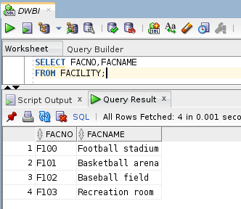

1. Executing Insert Statement

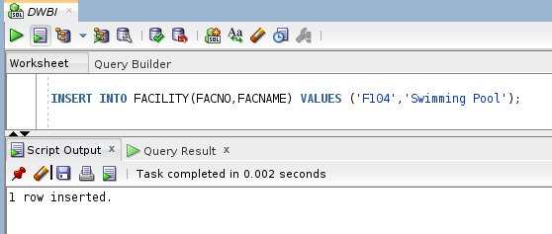

1. After inserting

